

Fire Fighting Robot for Industrial Purposes

**Group-5 Sec- C**

|  |  |  |  |  |
| --- | --- | --- | --- | --- |
| **SL** | **Name** | **ID** | **Program** |  |
| 22 | Kabir, Kazi Shahadat | 18-36341-1 | EEE |
| 25 | Jahan, Nushrat | 18-36586-1 | CSE |
| 32 | Nabil, Md. Abdullah | 18-37807-2 | EEE |
| 34 | Tahrim, H M | 18-37826-2 | EEE |
| 36 | Raza, Kala | 18-37869-2 | EEE |
| 37 | Ratul, S.M. Zobaeir Akando | 18-37880-2 | EEE |
| 38 | Rafat, Sadman Sakib | 18-37887-2 | EEE |
| 40 | Tasin, Raisa Tabassum | 18-37941-2 | EEE |
| 46 | Prince, Ahmed Tamim Zabir | 18-37382-1 | EEE |

Name of the Supervisor

**Nadia Nowshin**

*Assistant Professor*

**Spring** Semester **2020-2021**,

April, 2021



# © Faculty of Engineering, American International University – Bangladesh

Fire Fighting Robot

Prince, Ahmed Tamim Zabir, Kabir, Kazi Shahadat, Nabil, Md. Abdullah, Ratul, S.M. Zobaeir Akando, Rafat, Sadman Sakib, Raisa, Tabassum Tasin , Tahrim, H M , Jahan, Nushrat, Raza, Kala

Department of Electrical and Electronics Engineering,

American International University-Bangladesh (AIUB) Dhaka, Bangladesh

[sakib.rafat@ieee.org,](mailto:sakib.rafat@ieee.org) [nabilabdullah@ieee.org](mailto:nabilabdullah@ieee.org)

***Abstract*— Fire incident is a disaster that can potentially cause the loss of life, property damage and permanent disability to the affected victim. Fire fighters often exposed to higher risks. With the advent of technology, humans are replaced with robots in life-threatening situations. We aim to design a robot capable of detecting and suppressing fires. By designing and implementing a firefighting robot capable of detecting and extinguishing flames, disasters can be avoided with minimal risk to human life. This paper demonstrates the simulation and implementation of an autonomous firefighting robot which can automatically sense the smoke, fire and start to pump water over the flames. Flame and gas sensors were used to detect the fire and smoke. These two sensors can automatically detect fire and smoke & the robot navigates itself to the source of the fire & start extinguishing it by using the fire extinguishing system. This robot also consists with a container on top of the servo motor in order to control the path where water is being sprayed on. Two DC motors were used to control the motor movement while the robot is on operation mode to extinguish the fire.**

***Keywords— Firefighting Robot, Arduino UNO, Flame Sensor, Smoke Sensor, Water Pump.***

1. INTRODUCTION

Robot, any automatically operated machine that replaces human effort, though it may not resemble human beings in appearance or perform functions in a humanlike manner. The modern term robot derives from the Czech word robota (“forced labour” or “serf”), used in [Karel](https://www.britannica.com/biography/Karel-Capek) [Čapek](https://www.britannica.com/biography/Karel-Capek)’s play [R.U.R.](https://www.britannica.com/topic/RUR) (1920). [1] There are multiple ways robots are being used to improve safety. As well as removing people from hazardous situations, they may be an integral part of a system in partial control such as an aircraft autopilot. As tools that physically collaborate with people, they can act as assistants to prevent injury, for example as a body exoskeleton during lifting. They can perform inspection of assets such as structures or pressure vessels more frequently, with greater access, more sensors and less down time than people, leading to earlier defect detection and greater reliability. They can operate in environments where humans cannot go, for example undersea mining and drilling or entering collapsed buildings. Finally, they can be used in safety critical situations to detect and reduce errors, for example in robotic surgery tracking adjacency to obscured critical blood vessels and providing warnings through an appropriate interface.[2] Fire is a classical element that has been an equalizer on Earth prior to the start of written history. It has many positive attributes (heat, energy, cleansing, etc.) but it can be extremely dangerous when outside of control. Structure, vehicle, aircraft ship fires and wildfires can wreak havoc and cause serious injury and/or death. [3] When the fire gets out of control, firefighters are called. But while rescuing people they often get injured because of extreme fire. By using a firefighting robot this kind of accident can be reduced. Fire fighting is an important

job but it is very dangerous occupation. Due to that, Robots are designed to find a fire, before it rages out of control. It could be used to work with fire fighters to reduce the risk of injury to victims and firefighters too.[4] In this paper, a firefighting robot is proposed. Our robotic firefighting system is designed with certain tasks in mind. It includes analyzing and locating fires, conducting search and rescue, monitoring hazardous variables and the primary task of fire control and suppression. In purpose of rescuing people, the robot monitors the environment thermal state and go towards the fire location and extracts water from the pump from specific angle to another angle again and again till the fire blown out. This way it can reduce risk, expand profitability and effectiveness in rescuing.

1. LITERATURE REVIEW

J. Reinhart V. Khandwala (2003) was all discussed about design and the implementation of the fire-fighting robot. The key design elements of the robot to be discussed include: the assembly and construction of the robot hardware, the processing algorithm based on the sensor’s response, and the navigation algorithm that will enable the robot to find an efficient path in and out of the house model.[5] Lynette Miller Daniel Rodriguez (2003) was all discussing the development of each component of the robot that is designed to find a small fire represented by a light emitting diode in a model home and extinguish it. This paper will talk about each component of the robot from the start signal to the robot platform to the line following and room finding and finishing with the fire detection.[6] Sahil S.Shah (2013) was all discussed about design a FIRE FIGHTING ROBOT using embedded system. A robot capable of fighting a simulated household fire will be designed and built. It must be able to autonomously navigate through a modeled floor plan while actively scanning for a flame. The robot can even act as a path guider in normal case and as a fire extinguisher in emergency. Robots designed to find a fire, before it rages out of control, can one day work with fire-fighters greatly reducing the risk of injury to victims. The result shows that higher efficiency is indeed achieved using the embedded system.[7] U.Jyostna Sai Prasanna, M.V.D.Prasad (2013) was design the fire detection system using four flame sensors in the firefighting robot, and program the fire detection and fighting procedure using sensor based method. The firefighting robot is equipped with four thermistors/flame sensors that continuously monitor the temperature. If the temperature increases beyond the predetermined threshold value, buzzer sounds to intimate the occurrence of fire accident and a warning message will be sent to the respective personnel in the industry and to nearby fire station with the GSM module provided to it. [8] Swati A. Deshmukh (2015) was all discussed about the fire detection system using sensors in

the system, and program the fire detection and fighting procedure using sensor-based method. [9]

1. BASIC IDEA OF THE PROJECT

In the age of modern world, robotics has turned out to be an ingredient over which many people had shown their interest. With the development in the field of robotics, human intrusion has become less and robots are being widely used for safety purpose. Basically, robotics is used in such scenario where we humans cannot execute the work in a harmonic way. In our day-to-day life we can observe such scenario where humans may face troubles to keep with the pace. Such scene is Fire Accidents. In case, fire accidents have become a common disaster for our daily life. Sometimes it may lead to hazards that make it hard for the firemen to protect human life. In such cases, a firefighting robot can be highly useful to guard human lives, wealth, and surroundings from the fire accidents. So concerning about the facts, we have decided to design a fully automated firefighting robot which can help in dealing with many fire problems in households, office, industries etc. To do so, we have implemented a software-based Fire Fighting Robot with the help of Proteus 8.9 Professional and Arduino IDE software. It is designed to sense any kind of fire or smoke by the help of sensors and extinguish it by spreading water continuously until the fire and smoke goes off. As it is fully automated robot and it responses to the fire accident instantly, this robot will definitely help to secure many lives and damages as well as times. Finally, this robot is much helpful and beneficial for our society and modern life as it can keep up with the task more quickly than the humans.

TABLE I. Components of the Project

|  |  |
| --- | --- |
| **Equipment** | **Quantity** |
| Arduino Uno | 1 |
| Flame Sensor | 3 |
| Gas Sensor | 1 |
| Buzzer | 1 |
| DC Motor | 2 |
| Servo Motor | 1 |
| L293D | 1 |
| Dc Pump | 1 |
| Logic State Switch | 4 |

Fig.1. show the block diagram for the implementation of the robot which has been followed through this whole capstone project journey.

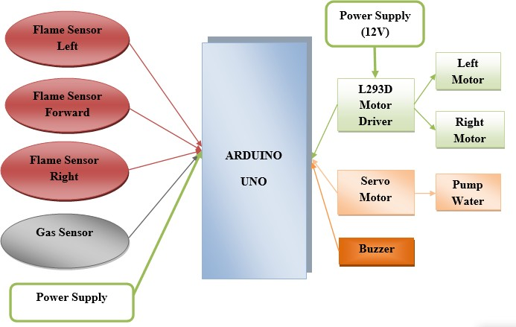

Figure.1. Block Diagram

1. SOFTWARE IMPLEMENTATION

To build the project firstly, we have opened a new project on the Proteus 8.9 Professional software. After that we took all the required equipment’s such as Arduino Uno, DC Motor, Servo Motor, L293D, Flame Sensor, Gas Sensor, Buzzer, Dc Pump and Logic State Switch one after another. Secondly, we opened the Arduino IDE software and implemented a code which will control all the working behavior of the microcontroller. When code was done, we get back to the Proteus environment and make all the connection as per the instruction provided in the code. We connect 5V supply voltage in each flame and gas sensors and 12V to the L293D. Then we bring one Virtual Terminal to see the expected output on the screen and connected its TX pin to the RX pin of microcontroller and RX pin to the TX pin of the microcontroller. After connecting all the connection, we have provided the hex file of the code in the Arduino Uno as input and run the simulation. After observing all the outputs, it can be saying that all the outputs were matched with the expected result. Thus, the software implementation was successfully achieved. Here, Figure 2 shows the schematic environment of our firefighting robot. All the connection was done as per the code instruction.

Figure 2 shows the safe mode of the robot and figure 3 shows the operating mode of the robot.

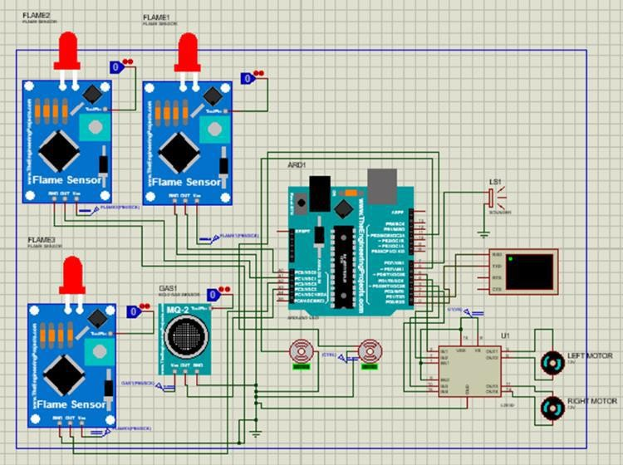

Fig.2. Schematic Environment of Fire Fighting Robot

Figure 3 shows the “Safe Environment” signal on the virtual terminal when no flames or gas detects.

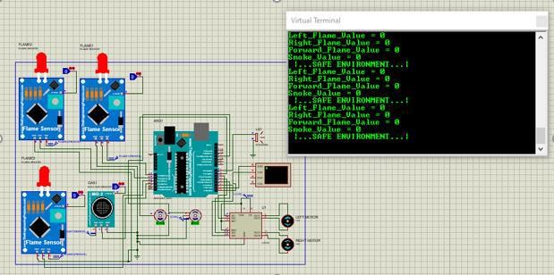

Fig.3. Output showing “Safe Environment” when no flame or smoke detects

Figure 4 shows the “Danger Environment: Warning!” signal on the virtual terminal when flame is detected on forward flame sensor.

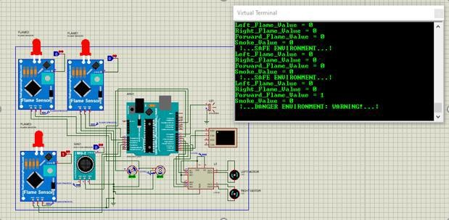

Fig.4. Output showing “Danger Environment: Warning!” when flame detects.

Figure 5 shows the “Danger Environment: Warning!” signal on the virtual terminal when smoke is detected.

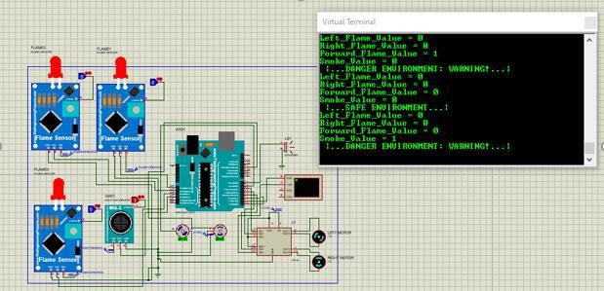

Fig.5. Output showing “Danger Environment: Warning!” when smoke detects.

1. RESULT AND DISCUSSION

In this project, an autonomous Firefighting Robot has been implemented which is capable of detecting flames & smokes and extinguishing them successfully. This robot can move forward, move left & right flawlessly. The motors and Arduino code work together to control the movement of the robot. If any of the flame sensors or smoke sensor are triggered, then buzzer will start to buzz & warning about the danger environment will be displayed on the Virtual Terminal & safe environment will be shown in case of no such detection. The motor will start to rotate & move the robot to the danger point upon receiving a signal about the danger environment & start to pump the water with the help of servo motor. This process will be continued until the fire or smoke has been extinguished completely. Then it will display about the safe environment. After successfully building the project, the simulation was run and the desired output was obtained. Proper snapshots of the results were attached. Thus, an autonomous firefighting robot has been built to achieve the objectives of this project successfully

1. FUTURE WORK

Future work can include the transformation of the experimental robot prototype into a practical robot, which requires improvement in its overall performance. Face detection system are developed for a fire-fighting robot to rescue human beings caught in fire. The face detection system alerts the presence of human beings caught in fire to facilitate their rescue. The ultrasonic sensor can also be

attached to detect any object around the robot to avoid any collision with other objects. Wireless remote-control idea can be introduced to this system so that human can control the mechanism of the robot by their own needs. and its performance can be enhanced by interfacing it with a wireless higher Resolution zooming Camera so that the person controlling it can view the operation of the robot remotely on a screen.

1. CONCLUSION

The Fire Fighting Robot is effective enough to fight against fire on a small scale. It can sense fire flame better at darker places. It is made as a preventer robot. Because it can detect fire instantly and can extinguish it before spreading. This multisensory based robot may be a solution to all fire hazards. Various sensors like flame, smoke sensors have been incorporated in this robot. If the fire is detected, a water spraying mechanism is triggered to extinguish the fire. Sound alert is also issued upon all events to alert the operator. With enough funding and scope, this design of robot can also fight against large fire with larger reserving capacity and an improved sensing unit can provide even an earlier detection of fire at all circumstances. As a conclusion, the project entitled “Fire Fighting Robot” has achieved its aim and objective successfully.

REFERENCES

1. “oscilloscope | Definition & Facts” https://[www.britannica.com/technology/oscilloscope](http://www.britannica.com/technology/oscilloscope)
2. “Foresight review of robotics and autonomous systems” [https://www.lrfoundation.org.uk/en/publications/foresight- reviewofroboticsandautonomoussystemsras/?gclid=CjwKC AjwjuqDBhAGEiwAdX2cjx4t2_VZvzb9dI32z83Pm5- iSG5QU4Hl2cecqinoFay6SIdmMKgEhoC6KAQAvD_BwE](https://www.lrfoundation.org.uk/en/publications/foresight-reviewofroboticsandautonomoussystemsras/?gclid=CjwKCAjwjuqDBhAGEiwAdX2cjx4t2_VZvzb9dI32z83Pm5-iSG5QU4Hl2cecqinoFay6SIdmMKgEhoC6KAQAvD_BwE)
3. The Use of Robotics in Firefighting | EKU Online [https://safetymanagement.eku.edu/blog/the-use-of-robotics- infirefighting/#:~:text=Robotic%20firefighting%20systems](https://safetymanagement.eku.edu/blog/the-use-of-robotics-infirefighting/#%3A~%3Atext%3DRobotic%20firefighting%20systems%20are%20designed%2Cof%20fire%20control%20and%20suppression)

[%20are%20designed,of%20fire%20control%20and%20sup](https://safetymanagement.eku.edu/blog/the-use-of-robotics-infirefighting/#%3A~%3Atext%3DRobotic%20firefighting%20systems%20are%20designed%2Cof%20fire%20control%20and%20suppression) [pression](https://safetymanagement.eku.edu/blog/the-use-of-robotics-infirefighting/#%3A~%3Atext%3DRobotic%20firefighting%20systems%20are%20designed%2Cof%20fire%20control%20and%20suppression)

1. M. S. M. Hasimi, W. H. W. Zuha, Suhaidi Shafie, M. Hamiruce Marhaban,”Fire Fighting Robot”, in Malaysia,

July 2010

1. J. Reinhart, V. Khandwala, T. Shah, J. Young, L. Ross

R. Delica, F. Angus, J. Burford, B. Lynch, R. Pollard, "Design and Implementation of Fully Autonomous Fire- Fighting Robot for a Small House Model", paper at Florida Atlantic University, Boca Raton, 2003

1. Lynette Miller ,Daniel Rodriguez ,Kristen Allen, Maksim Makeev “Firebot: Design of an Autonomous Fire Fighting Robo[t”http://](http://mil.ufl.edu/)m[il.u](http://mil.ufl.edu/)f[l.edu/](http://mil.ufl.edu/) publications/fcrar03/Firebot.pdf
2. Sahil S.Shah , Vaibhav K.Shah, Prithvish Mamtora and Mohit Hapani FIRE FIGHTING ROBOT nternational Journal of Emerging Trends & Technology in Computer Science (IJETTCS) Volume 2, Issue 4, July – August 2013
3. U. Jyostna Sai Prasanna, M.V.D Prasad, “Automatic Fire Sensing And Extinguishing Robot Embedded With Gsm Modem.” (IJEAT) ISSN: 2249 -8958,Volume-2, Issue4,April 2013.
4. Swati Deshmukh, Karishma Matte and Rashmi Pandhare, “Wireless Fire Fighting Robot”, International journal for research in emerging science and technology, vol.-2, pp.373 - 375, March-2015.

APENDIX

**}**

# for (pos = 130; pos >= 50; pos -= 1) { myservo.write(pos);

**delay(10);**

**}**

**delay(100); digitalWrite(pump, LOW);**

**Fire Fighting Robot Code implemented using Arduino IDE software:**

**#include <Servo.h> Servo myservo;**

**/*-------defining Inputs */**

**int Left_S = A0; // left sensor int Right_S = A1; // right sensor**

**int Forward_S = A2; //forward sensor int Smoke_S = A3; //smoke sensor**

**int pos = 0;**

**/*-------defining Outputs */**

**int LM1 = 2; // left motor int LM2 = 3; // left motor int RM1 = 4; // right motor int RM2 = 5; // right motor int pump = 6;**

**int Buzzer = 7;**

**void setup()**

**{**

**pinMode(Left_S, INPUT); pinMode(Right_S, INPUT); pinMode(Forward_S, INPUT); pinMode(Smoke_S, INPUT); pinMode(LM1, OUTPUT); pinMode(LM2, OUTPUT); pinMode(RM1, OUTPUT); pinMode(RM2, OUTPUT); pinMode(pump, OUTPUT); pinMode(Buzzer, OUTPUT);**

**Serial.begin(9600); myservo.attach(11);**

**}**

**void put_off_fire()**

**{**

**delay (500);**

**digitalWrite(LM1, LOW); digitalWrite(LM2, LOW); digitalWrite(RM1, LOW); digitalWrite(RM2, LOW);**

**digitalWrite(pump, HIGH); delay(500);**

**for (pos = 50; pos <= 130; pos += 1) { myservo.write(pos);**

**delay(10);**

**}**

**void loop()**

**{**

**int flameval1 = digitalRead (Left_S) ; int flameval2 = digitalRead (Right_S) ;**

**int flameval3 = digitalRead (Forward_S) ; int smokeval = digitalRead(Smoke_S); Serial.print("Left_Flame_Value = "); Serial.println(flameval1); Serial.print("Right_Flame_Value = "); Serial.println(flameval2); Serial.print("Forward_Flame_Value = "); Serial.println(flameval3); Serial.print("Smoke_Value = "); Serial.println(smokeval);**

**if (flameval1 == LOW and flameval2 == LOW and flameval3 == LOW and smokeval == LOW) //If Fire OR Smoke not detected all sensors are zero**

**{**

**//Do not move the robot**

**Serial.println(" |...SAFE ENVIRONMENT...| "); digitalWrite(LM1, LOW);**

**digitalWrite(LM2, LOW); digitalWrite(RM1, LOW); digitalWrite(RM2, LOW); digitalWrite(Buzzer, LOW);**

**}**

**else if (flameval1 == HIGH or smokeval == HIGH) //If Fire OR Smoke is straight ahead**

**{**

**//Move the robot forward**

**Serial.println(" |...DANGER ENVIRONMENT: WARNING!...| ");**

**digitalWrite(LM1, HIGH); digitalWrite(LM2, LOW); digitalWrite(RM1, HIGH); digitalWrite(RM2, LOW); digitalWrite(Buzzer, HIGH);**

**put_off_fire();**

**}**

**else if (flameval2 == HIGH or smokeval == HIGH) //If**

**Fire OR Smoke is to the left**

**{**

**//Move the robot left**

**Serial.println(" |...DANGER ENVIRONMENT: WARNING!...| ");**

**digitalWrite(LM1, HIGH); digitalWrite(LM2, LOW); digitalWrite(RM1, LOW); digitalWrite(RM2, HIGH); digitalWrite(Buzzer, HIGH);**

**put_off_fire();**

**}**

**else if (flameval3 == HIGH or smokeval == HIGH) //If Fire OR Smoke is to the right**

**{**

**//Move the robot right**

**Serial.println(" |...DANGER ENVIRONMENT: WARNING!...| ");**

**digitalWrite(LM1, LOW); digitalWrite(LM2, HIGH); digitalWrite(RM1, HIGH); digitalWrite(RM2, LOW); digitalWrite(Buzzer, HIGH);**

**put_off_fire();**

**}**

**delay(300); //Slow down the speed of robot**

**}**